Student Activity
18 Newton’s second law II

TASK
To verify Newton’s second law, F = ma.

THEORY
According to Newton’s second law, F = ma. F is the net force acting on the object of mass m and a is the resulting acceleration of the object.
For a cart of mass m₁ on a horizontal track with a string attached over a pulley to a mass m₂ (see diagram), the net force F on the entire system (cart and hanging mass) is the weight of hanging mass, F = m₂g, assuming that friction is negligible.
According to Newton’s second law, this net force should be equal to ma, where m is the total mass that is being accelerated, which in this case is m₁ + m₂. This experiment will check to see if m₁g is equal to (m₁ + m₂)a when friction is ignored.
To obtain the acceleration, the cart will be started from rest and the time (t) it takes for it to travel a certain distance (s) will be measured. Then, as x = ()at², the acceleration can be calculated using a = 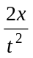 (assuming a = constant).

EQUIPMENT
• dynamics trolley
• pulley with clamp
• string
• stopwatch
• mass balance
• dynamics track (or simple board that can be levelled)
• mass hanger and mass set
• wooden or metal stopping block
• ruler

NOTES ON METHOD
1. Level the track by setting the cart on the track to see which way it rolls. Adjust the levelling feet, or place extra paper or books underneath, to raise or lower the ends until the cart will not move when placed at rest on the track.

2. Use the balance to find the mass of the cart and record the value.

3. Attach the pulley to the end of the track as shown below.
Place the dynamics cart on the track and attach a string to the hole in the end of the cart and tie a mass hanger on the other end of the string.
The string must be just long enough so that the cart hits the stopping block before the mass hanger reaches the floor.

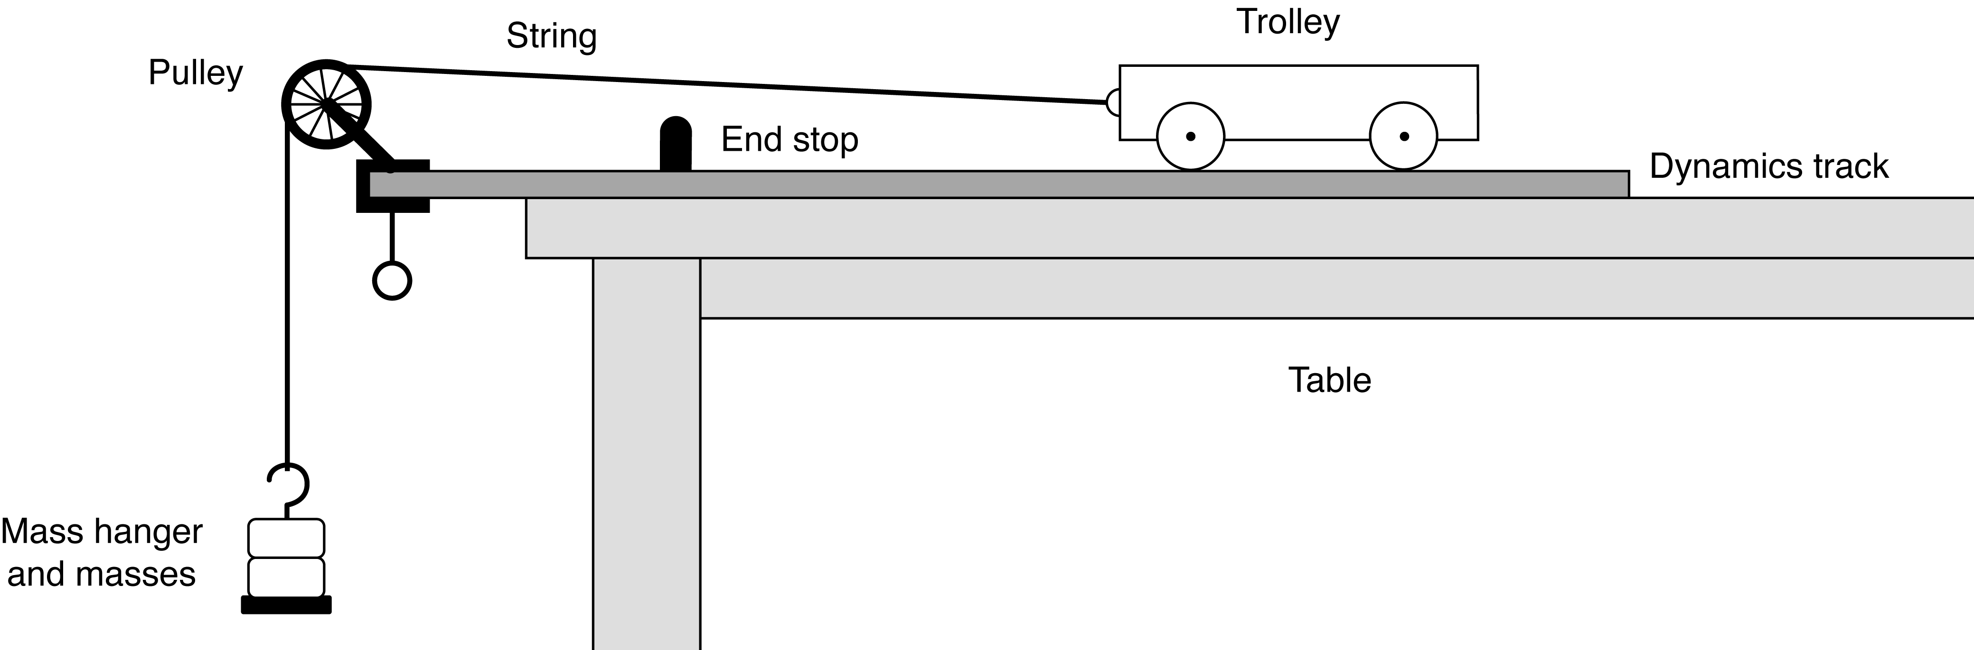

4. Pull the cart back until the mass hanger reaches the pulley.
Record this position and mark it on the track with chalk or a similar removable mark.
This will be the release position for all the trials.
continued
18 Newton’s second law II
4. (continued) Make a test run by simply releasing the cart to determine how much mass is required on the mass hanger so that the cart takes about 2 seconds to complete the run.
Because of reaction time, too short a total time will cause too much error.
However, if the cart moves too slowly, friction causes too much error.
Record the total hanging mass.

Increase the accuracy of the activity by measuring the acceleration of the cart with a motion sensor or photogates and graph the motion directly to a computer for analysis.
Place a small, playing size card across an air track glider to act as a reflector.

ICT
If available, make sure your motion sensor is set to ‘near’ to decrease the effect of stray echoes.
Sample rate: 10–20 Hz.
Graph: Position versus time, velocity versus time.
Calculate: acceleration, force.

5. Place the cart against the adjustable end stop on the pulley end of the track, and record the final position of the cart.

6. Measure the time at least five times. Record these values.

7. Increase the mass of the cart and repeat the procedure.

DATA & ANALYSIS
Based on your initial data:
1. Calculate the average times for all runs.
2. Calculate the total distance travelled by taking the difference between the initial and final positions of the cart as initially recorded.
3. Calculate the accelerations for each run.
4. For each case, calculate the total mass multiplied by the acceleration and record the values.
5. For each case, calculate the net force acting on the system and record the value.
6. Calculate the percentage difference between F_{NET} and (m₁ + m₂) a and record the value.
(This is a measure of the reliability of your determination of Newton’s second law.)

CONCLUSION
To what extent do your observations, measurements and calculations support, or not support, Newton’s second law? Comment on your results and the percentage difference recorded.

QUESTIONS
1. Why is the mass in F = ma not just equal to the mass of the car?
2. When calculating the force on the cart using mass × gravity, why isn’t the mass of cart included?

